Open remix write this contract and compile

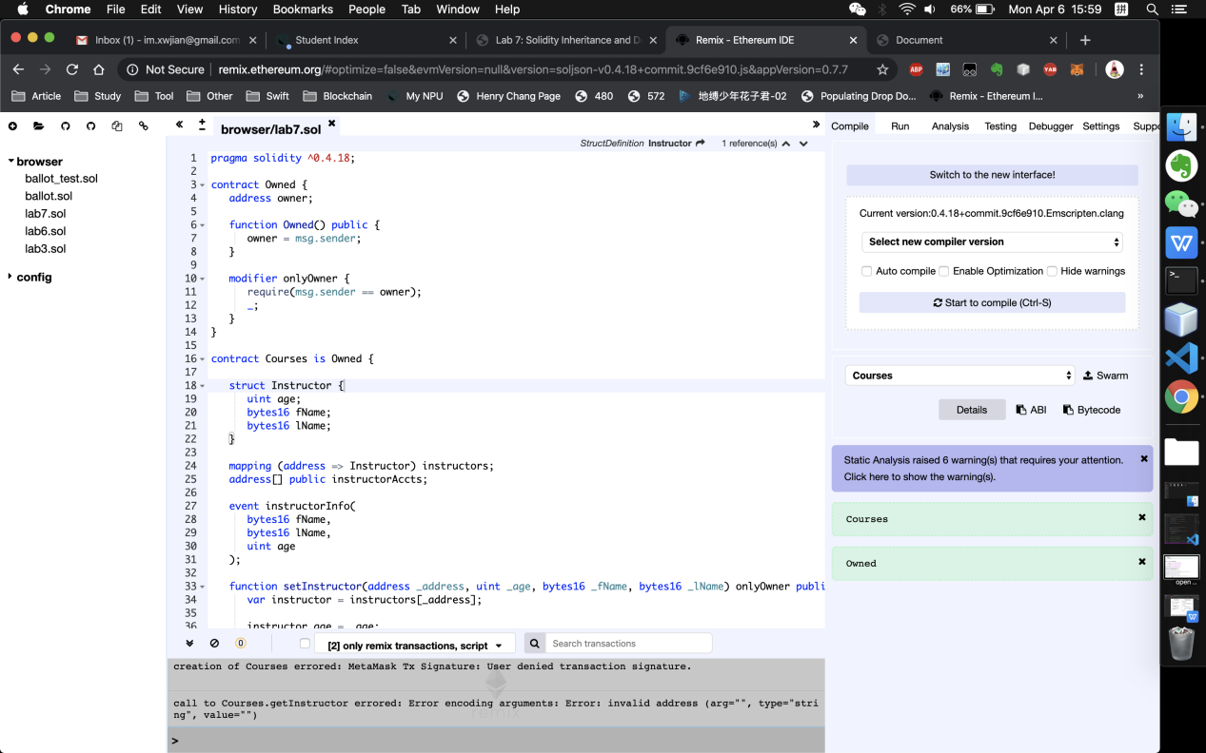

Then run with environment injected web3

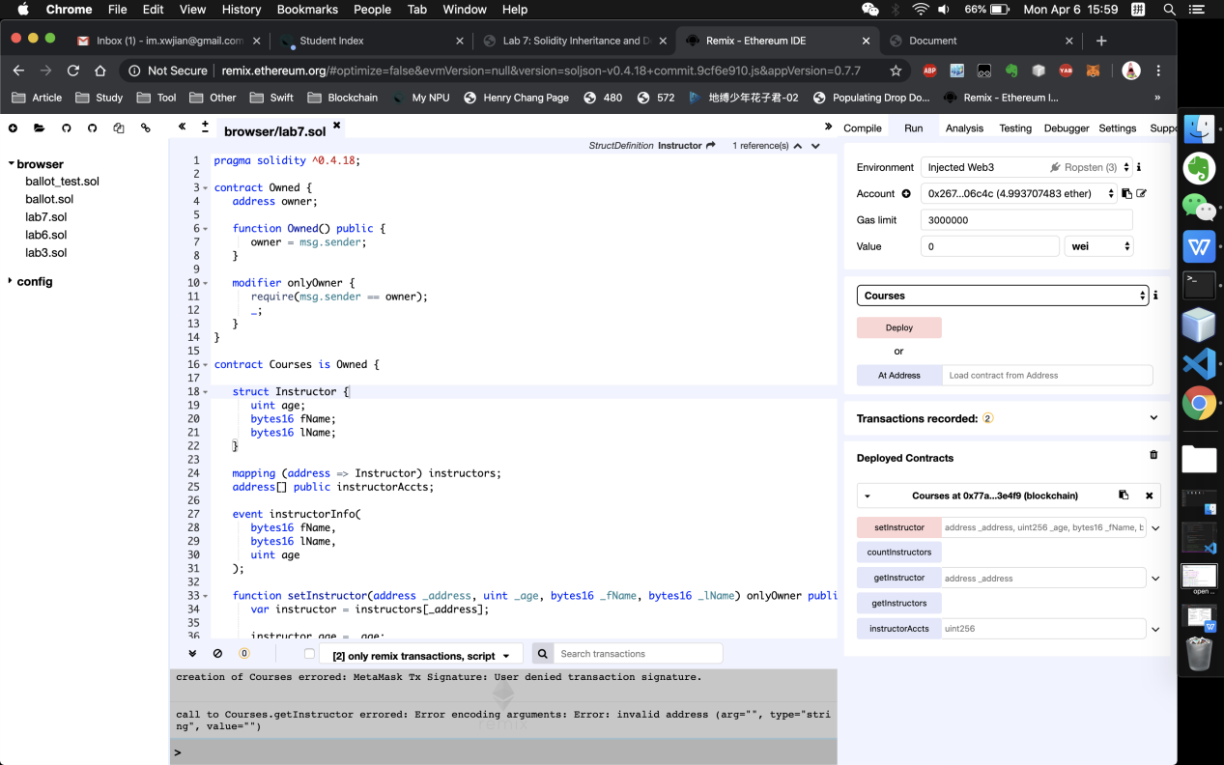

Metamask will pop up and confirm

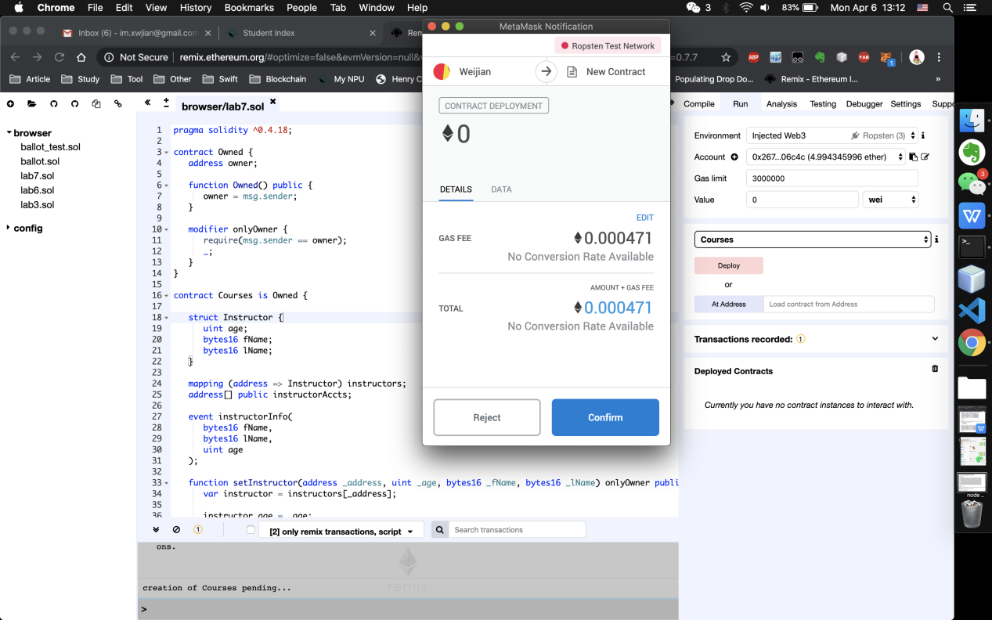

Create this index file in project folder. And copy your contract ABI and address in specific place.

<!DOCTYPE html>

<html lang="en">

<head>

<meta charset="UTF-8">

<meta name="viewport" content="width=device-width, initial-scale=1.0">

<meta http-equiv="X-UA-Compatible" content="ie=edge">

<title>Document</title>

<link rel="stylesheet" type="text/css" href="main.css">

<script src="./node_modules/web3/dist/web3.min.js"></script>

</head>

<body>

<!-- <div class="container">

<h1>Coursetro Instructor</h1>

<span id="countIns"></span>

<h2 id="instructor"></h2>

<span id="insTrans"></span>

<hr>

<img id="loader" src="https://loading.io/spinners/double-ring/lg.double-ring-spinner.gif">

<img id="loader" src="https://i.gifer.com/L6MI.gif">

<label for="fName" class="col-lg-2 control-label">First Name</label>

<input id="fName" type="text">

<label for="lName" class="col-lg-2 control-label">Last Name</label>

<input id="lName" type="text">

<label for="age" class="col-lg-2 control-label">Instructor Age</label>

<input id="age" type="text">

<button id="button">Update Instructor</button>

</div> -->

<div class="container">

<h1>Coursetro Instructor</h1>

<span id="countIns"></span>

<h2 id="instructor"></h2>

<span id="insTrans"></span>

<hr>

<img id="loader" src="https://i.gifer.com/L6MI.gif">

<label for="fName" class="col-lg-2 control-label">First Name</label>

<input id="fName" type="text">

<label for="lName" class="col-lg-2 control-label">Last Name</label>

<input id="lName" type="text">

<label for="age" class="col-lg-2 control-label">Instructor Age</label>

<input id="age" type="text">

<button id="button">Update Instructor</button>

</div>

<script src="https://code.jquery.com/jquery-3.2.1.slim.min.js"></script>

<script>

var web3;

if (typeof web3 !== 'undefined') {

web3 = new Web3(web3.currentProvider);

} else {

// set the provider you want from Web3.providers

web3 = new Web3(new Web3.providers.HttpProvider("http://localhost:8545"));

if(!web3.isConnected()) {

console.log('not-connected');

} else {

console.log('connected');

}

}

//////////////////////////////////////////////////////////////////////

// Default account should be accounts[0]

// web3.eth.defaultAccount = web3.eth.accounts[2];

/////////////////////////////////////////////////////////////////////

web3.eth.defaultAccount = web3.eth.accounts[0];

//////////////////////////////////////////////////////////////////

// The following highlighted area must be converted into one line.

// Please refer index.html

//////////////////////////////////////////////////////////////////

// var CoursetroContract = web3.eth.contract('PASTE ABI CODE HERE');

var CoursetroContract = web3.eth.contract(

[

{

"constant": false,

"inputs": [

{

"name": "_address",

"type": "address"

},

{

"name": "_age",

"type": "uint256"

},

{

"name": "_fName",

"type": "bytes16"

},

{

"name": "_lName",

"type": "bytes16"

}

],

"name": "setInstructor",

"outputs": [],

"payable": false,

"stateMutability": "nonpayable",

"type": "function"

},

{

"anonymous": false,

"inputs": [

{

"indexed": false,

"name": "fName",

"type": "bytes16"

},

{

"indexed": false,

"name": "lName",

"type": "bytes16"

},

{

"indexed": false,

"name": "age",

"type": "uint256"

}

],

"name": "instructorInfo",

"type": "event"

},

{

"constant": true,

"inputs": [],

"name": "countInstructors",

"outputs": [

{

"name": "",

"type": "uint256"

}

],

"payable": false,

"stateMutability": "view",

"type": "function"

},

{

"constant": true,

"inputs": [

{

"name": "_address",

"type": "address"

}

],

"name": "getInstructor",

"outputs": [

{

"name": "",

"type": "uint256"

},

{

"name": "",

"type": "bytes16"

},

{

"name": "",

"type": "bytes16"

}

],

"payable": false,

"stateMutability": "view",

"type": "function"

},

{

"constant": true,

"inputs": [],

"name": "getInstructors",

"outputs": [

{

"name": "",

"type": "address[]"

}

],

"payable": false,

"stateMutability": "view",

"type": "function"

},

{

"constant": true,

"inputs": [

{

"name": "",

"type": "uint256"

}

],

"name": "instructorAccts",

"outputs": [

{

"name": "",

"type": "address"

}

],

"payable": false,

"stateMutability": "view",

"type": "function"

}

]

);

console.log('created CoursetroContract');

// var Coursetro = CoursetroContract.at('PASTE CONTRACT ADDRESS HERE');

console.log('Creating Coursetro');

// ///////////////////////////////////////////////////////////////

// The following highlighted area must be customized for your smart

// contract.

// ///////////////////////////////////////////////////////////////

var Coursetro = CoursetroContract.at('0x77af6a598fd353ec46d58130f06b9d990b83e4f9');

console.log(Coursetro);

// Replace the Coursetro.getInstructor() lines with this line:

// var instructorEvent = Coursetro.Instructor();

var instructorEvent = Coursetro.instructorInfo({}, 'latest');

// Watch the event

instructorEvent.watch(function(error, result) {

if (result) {

if (result.blockHash != $("#insTrans").html())

$("#loader").hide();

$("#insTrans").html('Block hash: ' + result.blockHash);

$("#instructor").html(web3.toAscii(result.args.fName) + ' '

+ web3.toAscii(result.args.lName)

+ ' (' + result.args.age + ' years old)');

} else {

$("#loader").hide();

}

});

Coursetro.countInstructors((err, res) => {

if (res)

$("#countIns").html(res.c + ' Instructors');

})

// if the button "Update Instructor" is pressed.

$("#button").click(function() {

$("#loader").show();

Coursetro.setInstructor(web3.eth.defaultAccount, $("#age").val(),

$("#fName").val(), $("#lName").val(), (err, res) => {

if (err) {

$("#loader").hide();

}

});

});

</script>

</body>

</html>

Open terminal to your project directory type “npm run dev”, it will open index file automatically.You can see now 0 instructor, once you type all information then click “Update instructor” this metamask window will pop up and show you gas fee.

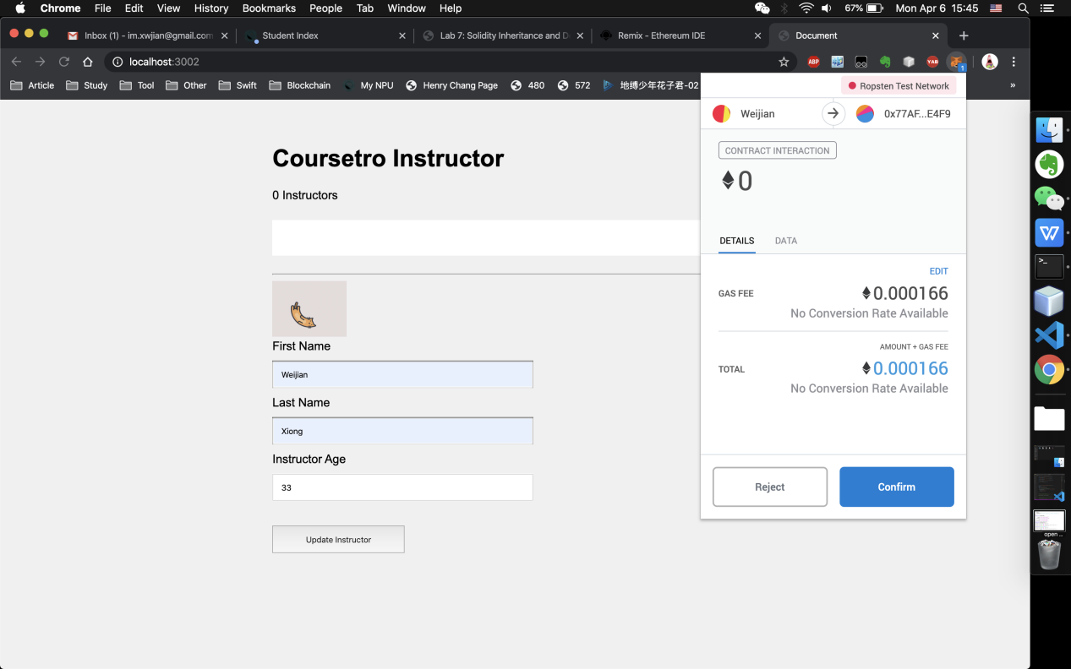

After you click confirm, its status is pending.

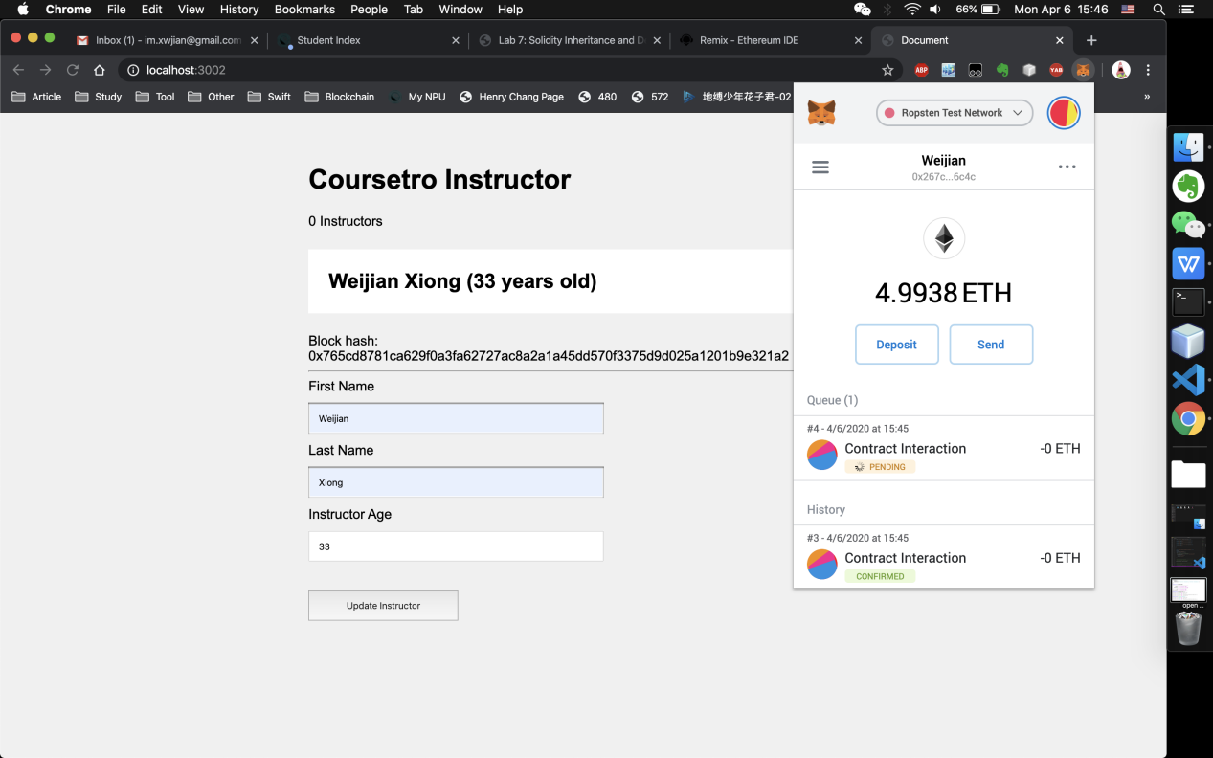

After it confirms

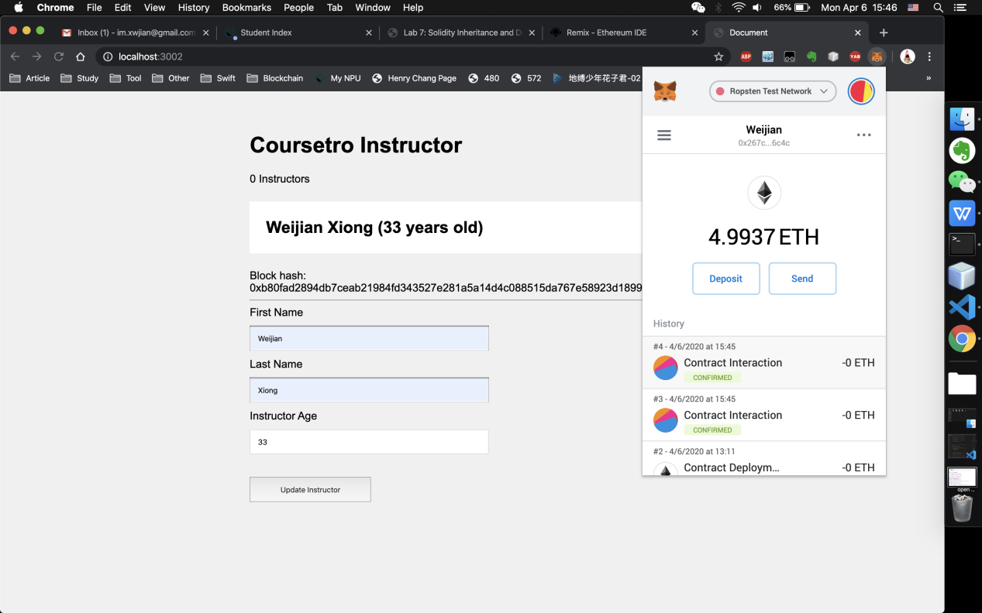

After you update several instructors, the page counts how many instructors you updated.

